**REPORT BY**

**NAME:KUSHAL SHAH**

**STUDENT ID:A20207420**

**EMAIL ID:kusshah@okstate.edu**

**Interpretations from Models:**

* Our model can predict whether someone will have a improvement in pain or not with accuracy.(see Figure 1 for reference).
* Prediction of whether someone will have improvement in pain or not depends upon type of treatment performed and gender. (see Figure 2 for reference)
* Accuracy of prediction by this model is 67.85% (see Figure 4 for reference)
* Type of treatment impacts more than gender for prediction of outcome.(whether someone will have a improvement in pain or not)- ( see Figure 3 for reference)
* Active treatment tends to improve pain after treatment more than Placebo treatment. (see Figure 5 for reference)
* Out of Females and Males, Females tend to have high chances of getting improvement in pain from treatment. (see Figure 5 for reference)

**Recommendation based on model:**

* Active drug treatment tend to show more improvement in pain, so this drug might pass FDA approval(depends upon FDA criteria). ( see Figure 6 for reference.)
* Majority of target audience would be female (more than male) for marketing campaign. In that way, it would higher chances of improvement in pain in target audience.

**Apendix:**

**Technical Summary.**

**1)**

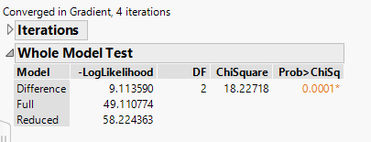 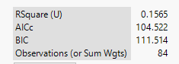

Figure 1

H0: LR model does not explain relationship between the Gender,Treament(independent) and Improvement(dependent) variable any better that random model.

Ha:: H0 is not true

Prob> Chisq value-0.0001 suggest that we can reject null hypothesis

This suggest that this model is statistically significant to predict improvement.

**2)**

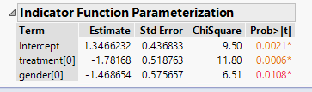

Figure 2

H0: Values of regression coefficient of Gender and Treatment equals to 0 in population.

Ha: H0 is not true

Probability values for intercept, treatment and gender shows that we can reject null hypothesis. That means that both variables are statistically significant in the model.

**3)**

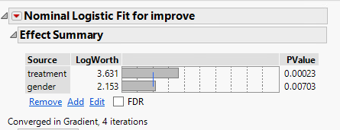

Figure 3

Value of logworth for treatment and gender suggest that change in Treatment would change the prediction value more than change in Gender value. That says that Treatment is more important variable than gender for prediction

**4)**

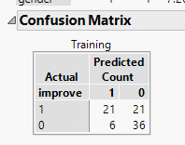

Figure 4

From confusion matrix, we can say that counts if true negative+ true positive= 21+36=57

Total misclassified: 6+21=27

Misclassification rate:27/84=32.15%

**Comment**: Sensitivity and specificity

**5)**

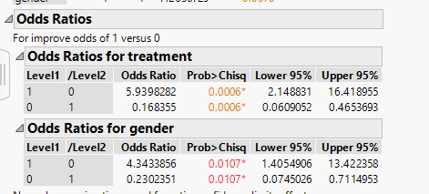

Figure 5

Above figure suggest odds ratio. For any of treatment, we can say Female(Gender=1) is 4.34 time more likely to have improvement in pain than Male

For any of gender, Active Treatment(Level=1) have 5.93 time more likely to give improvement in pain that Placebo treatment.

**6)**

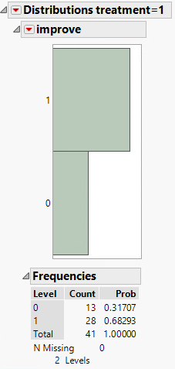

Figure 6

Active drug treatment tend to improve pain in 68.29% of cases.

**Validation of Assumption:**

**1)**

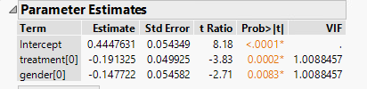

VIF value of 1.0088457(<10) shows no serious multicolinearity issue.

**Comment**: Report should be detailed and neatly strucutured.

Perform forward,stepwise and backward variable detection.